H₂ Leak Detector
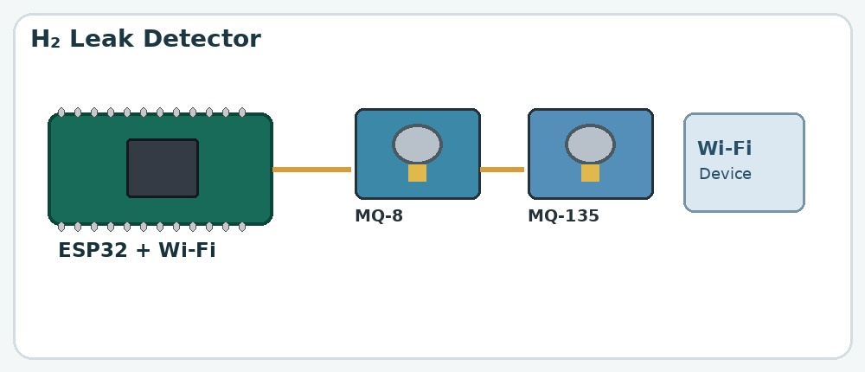

Aim
To detect the presence of hydrogen gas and monitor changes in air quality, with readings transmitted wirelessly over Wi-Fi.

What is the project?
A gas-monitoring system that uses gas sensors and an ESP32 microcontroller to detect changes in gas concentration and send readings to a connected device.

How does it work?
- The MQ-8 sensor responds to hydrogen gas, while the MQ-135 responds to certain other gases and changes in air quality.
- The sensors produce electrical signals that vary with the gases they detect.
- The ESP32 reads and processes the sensor signals according to its program.
- Using its built-in Wi-Fi, the ESP32 can send readings to a compatible device or dashboard.
- The connected device displays readings or an alert if that feature is programmed.

Components used
- ESP32 microcontroller
- MQ-8 hydrogen gas sensor
- MQ-135 air-quality sensor
- OLED display
- Buzzer
- Breadboard
- Jumper wires
- Wi-Fi-connected device for monitoring

Connections
Component / Pin | Typical connection
MQ-8 VCC | Breadboard positive
MQ-8 GND | Breadboard negative
MQ-8 output | Pin 34 (ESP)
MQ-135 VCC | Breadboard positive
MQ-135 GND | Breadboard negative
MQ-135 output | Pin 35 (ESP)
ESP32 5V | Breadboard positive
ESP32 GND  Buzzer positive  OLED SCL/SCK  OLED SDA | Breadboard negative  Pin 25 (ESP)  Pin 22 (ESP)  Pin 21 (ESP)

